

City of Clayton, California Annual Financial Report For the Year Ended June 30, 2022

INTRODUCTORY SECTION

City of Clayton

Comprehensive Annual Financial Report
For the year ended June 30, 2022
Table of Contents

 |  |  | Page
INTRODUCTORY SECTION
 |  |  | 1
Table of Contents……………………………………………………………………………….
Letter of Transmittal…………………………………………………………………………… |  |  | 4
Mission Statement……………………………………………………………………………... |  |  | 9
Organizational Chart…………………………………………………………………………... |  |  | 10
Principal Officers, Department Heads and Advisory Bodies |  |  | 11
Regional Map of Clayton and Nearby Cities |  |  | 12
FINANCIAL SECTION
Independent Auditors’ Report……………………………. . ………………………………… |  |  | 17
Management's Discussion and Analysis………………………. . . …………………………. . |  |  | 21
Basic Financial Statements
Government-Wide Financial Statements:
Statement of Net Position………………………………………………. . …………… |  |  | 33
Statement of Activities and Changes in Net Position………………………. . ……. |  |  | 34
Governmental Fund Financial Statements:
Balance Sheet……………………………………………………………. . ……………. |  |  | 39
Reconciliation of Governmental Funds Balance Sheet to the Statement of
Net Position………………………………………………………………………… |  |  | 42
Statement of Revenues, Expenditures and Changes in Fund Balances…………. . |  |  | 43
Reconciliation of the Governmental Funds Statement of Revenues, Expenditures and
Changes in Fund Balances to the Statement of Activities and Changes in Net
Position…. . . ……………………………………. . …………. . . |  |  | 45
Proprietary Fund Financial Statements:
Statement of Net Position………………………………………. . …………………… |  |  | 47
Statement of Revenues, Expenses and Changes in Net Position…………. . . ……. . |  |  | 48
Statement of Cash Flows……………………………………………………. . ………. |  |  | 49
Fiduciary Fund Financial Statements:
Statement of Fiduciary Net Position…………………………………. . ……………. . |  |  | 51
Statement of Changes in Fiduciary Net Position……………………. . ……………. |  |  | 52
Notes to Basic Financial Statements…………………………………. . ……………………. . |  |  | 55

1

City of Clayton

Comprehensive Annual Financial Report
For the year ended June 30, 2022
Table of Contents

FINANCIAL SECTION (Continued)
Required Supplementary Information
Budgetary Comparison Schedules
General Fund……………………………………………………. . . …………………… |  | 103
Landscape Maintenance District ……………. …………. . . …………………………. |  | 104
Successor Housing Agency………. . ……………. . . …………………………………. . |  | 105
American Rescue Plan Act………. . ……………. . . …………………………………. . |  | 106
Pension Plan Funding Status
Schedule of Proportionate Share of Net Pension Liability…. . ……………………. |  | 107
Schedule of Pension Plan Contributions…. . …. . . …………………………………… |  | 108
Other Postemployment Benefits Plan Funding Status
Schedule of Changes in the Net OPEB Liability and Related Ratios. ……………. |  | 109
Schedule of OPEB Plan Contributions……. . …. . . …………………………………… |  | 110
Notes to the Required Supplementary Information…………………………………………. |  | 111
Supplementary Information
Major Funds
Budgetary Comparison Schedules. . . . . …………………………………………. . …… |  | 114
Non-Major Governmental Funds Financial Statements:
Combining Balance Sheet………………………………………………………. . …… |  | 117
Combining Statement of Revenues, Expenditures and Changes in Fund
Balances………………………………………………………. . . …………………… |  | 119
Budgetary Comparison Schedules……………………………………. . ……………. |  | 121
Internal Service Funds:
Combining Statement of Net Position. . . ………………………………. . …………… |  | 133
Combining Statement of Revenues, Expenses and Changes in Net
Position…………………………………………………………. . . …………………. |  | 134
Combining Statement of Cash Flows………………………………. . ……………… |  | 135
Agency Funds:
Combining Statement of Changes in Assets and Liabilities………………. . ……. . |  | 137

2

City of Clayton

Comprehensive Annual Financial Report
For the year ended June 30, 2022
Table of Contents

STATISTICAL SECTION (UNAUDITED)
Statistical Section Table of Contents………………………………………………….. |  | 142
Financial Trends
Net Position by Component…………………………………………………………… |  | 143
Changes in Net Position………………………………………………………………. |  | 145
Fund Balances of Governmental Funds………………………………………………. |  | 147
Changes in Fund Balances of Governmental Funds………………………………….. |  | 149
Revenue Capacity
Property Tax Levies and Collections…………………………………………….......... |  | 151
Assessed Value and Estimated Actual Value of Taxable Property…………………… |  | 152
Taxable Assessed Value by Source……………………………………………… |  | 153
Property Tax Rates……………………………………………………………………. |  | 155
Principal Property Tax Payers……………………………………………………….. |  | 157
Debt Capacity
Ratios of Debt Outstanding………………………………………………………....... |  | 159
Computation of Direct and Overlapping Debt……….………………………………. |  | 160
Legal Debt Margin…………………………………………………………………..... |  | 161
Bonded Debt Pledged Revenue Coverage……………………………………………….. |  | 163
Demographic and Economic Information
Demographic and Economic Statistics………………………………………………… |  | 164
Operating Information
Full-time Equivalent City Employees by Function……………………………………. |  | 165
Operating Indicators by Function……………………………………………………… |  | 167
Capital Asset Statistics by Function…………………………………………………… |  | 169
General Information……………………………………………………………………. |  | 171
ADDITIONAL REPORTS
Independent Auditors’ Report on Internal Controls over Financial Reporting
and on Compliance and other Matters Based on an Audit of Financial Statements
Performed in Accordance with Government Auditing Standards……………………. |  | 173

3


 |  |  | CITY COUNCIL
COMMUNITY |  |  | CARL “CW” WOLFE, MAYOR
 |  |  | PETER CLOVEN, VICE MAYOR
DEVELOPMENT | (925) 673‐7340 | 6000 HERITAGE TRAIL CLAYTON, CALIFORNIA 94517‐1250 | JEFF WAN, COUNCILMEMBER
ENGINEERING | (925) 969‐8181 | TELEPHONE (925) 673‐7300 FAX (925) 672‐4717 | JIM DIAZ, COUNCILMEMBER
 |  |  | HOLLY TILLMAN, COUNCILMEMBER

January 23, 2023

Honorable Mayor and Members of the City Council
City of Clayton

We are pleased to submit the City of Clayton’s Annual Comprehensive Financial Report (ACFR) for the Fiscal year ended June 30, 2022. Since its incorporation, the City has submitted an annual audited Financial Report to the City Council and its citizens in accordance with California Government Code section 25253. The ACFR provides the public, businesses, property owners, investors and all interested parties with an overview of the City’s finances. It is important to note the acronym for this report has changed from CAFR to ACFR as the prior acronym can be considered an offensive racial slur and is no longer used. The information in this ACFR is prepared in accordance with Generally Accepted Accounting Principles (GAAP) and includes an “unmodified opinion” (the highest rating) on the report by an independent certified public accounting firm, Cropper Rowe, LLP.

Although we rely on the standards and expertise of these independent auditors, the responsibility for the accuracy and fair representation of the ACFR ultimately rests with City management. We believe the data presented in this Report is accurate in all material respects and all statements and disclosures have been included necessary for the reader to obtain a thorough understanding of the City’s financial activities. Management of the City has established an internal control framework that is designed both to protect the City’s assets from loss, theft, or misuse and to compile reliable and timely information for the preparation of the City’s financial statements in conformity with GAAP. Because the cost of internal controls should not outweigh its benefits, the City’s framework of internal controls has been designed to provide reasonable rather than absolute assurance that its financial statements will be free from material misstatements.

For readers interested in a more detailed review of the City’s financial statements, a section in the ACFR called “Management Discussion and Analysis” (MD&A) has been included in accordance with Government Accounting Standards Board (GASB) Statement 34, Basic Financial Statements – And Management’s Discussion and Analysis – For State and Local Governments. The MD&A recounts the financial highlights of the City and provides additional analyses on the variances and trends reported as part of the financial statements. The MD&A further discloses significant items impacting the financial condition of the City and is designed to be read in conjunction with this Letter of Transmittal.

City Profile

The City of Clayton was incorporated in 1964 and is located in Contra Costa County, a suburban region in the eastern portion of the San Francisco-Bay Area. Pursuant to its adopted budget for the fiscal year ending June 30, 2022, the City has a permanent staff of 27.4 full- time equivalent employees which serves approximately 11,585 residents in a land area of approximately 4 square miles. Nestled in a small valley at the northern base of Mt. Diablo, the boundaries of the City are mostly developed with a

4

City of Clayton

Comprehensive Annual Financial Report
For the year ended June 30, 2022
Letter of Transmittal

City Profile, continued

strong community emphasis on open space preservation and maintenance of an extensive network of trails. The City continues to show strength as a safe community with attractive residential neighborhoods as a gateway to the fast paced and robust Bay Area economy.
The City operates under a Council- Manager form of government and provides many essential public services to the community. The City is governed by a five-member City Council elected at large, serving staggered terms of four years. The Mayor and Vice Mayor are selected by the City Council each year from its membership and serve one-year terms. The City Council is responsible for setting policies, adopting City ordinances, resolutions, the annual budget, appointing commissions and committees, and hiring the City Manager and City Attorney, among other key duties. The City Manager is responsible for implementing the City Council’s policies, ordinances and directives, overseeing the daily operations of the City, and appointing all department heads and through them all other employees of the City.

As presented in the City’s government-wide statement of activities, pursuant to GASBS 34, the City’s numerous departments and restricted- use funds accounting for public services are consolidated into higher-level programs, which include: public safety, public works, parks and recreation services, community and economic development, and general government. The public safety program is composed of an in-house police department, staffed with eleven (11) full-time sworn police officers and two (2) administrative personnel dedicated to the function of police services. Public works tracks the maintenance of public landscaping (i.e. street medians and shoulders, sub-division entryways, etc.), facilities, transportation infrastructure (i.e. streets, lighting, traffic signals, etc.), as well as contract City engineering services for management of the City’s Capital Improvement Program as well as land development regulatory needs. In their capacity of providing parks and recreation services, the City’s in-house maintenance department oversees the maintenance of the Clayton Community Library, the Clayton Community Park, The Grove Park, various neighborhood parks, and the historic Endeavor Hall rental facility. The community and economic development program consists of two (2) in-house staff providing planning and land-use regulatory services as well as the functions of economic development and affordable housing. Finally, the general government program reports legislative and support costs indispensable in providing in-house public services and maintains compliance an ever-expanding list of legal, fiscal and other statutory requirements imposed by the State of California.

The City’s fiscal year runs from July 1st through June 30th . Each year, the City Manager presents an annual budget to the City Council for adoption by Resolution on or before June 30th in accordance with Clayton Municipal Code section 3.02.040. On an interim basis the budget is monitored continually with the budgetary level of control maintained at the fund level.

Economic Condition and Outlook

Essentially a cul-de-sac hugging the base of acclaimed Mt. Diablo, Clayton maintains a small-town atmosphere while its relative proximity to California State Highway 24 and neighboring city BART stations make it ideal for commuters. In addition, the semi-rural setting, low crime rate and excellent middle and elementary public schools make Clayton attractive to families of all types.

5

City of Clayton

Comprehensive Annual Financial Report
For the year ended June 30, 2022
Letter of Transmittal

Economic Condition and Outlook, continued

Its residents are generally highly educated with approximately 57.8% of adults greater than age 25 having a bachelor’s degree or higher. In June of 2022, the unemployment rate of the City was 3.0%, compared to 3.20% and 4.0% for Contra Costa County and the State of California, respectively. In 2020 the median household income in the City was $153,607 compared to $87,355 for the state. The median age of Clayton residents is 43.1 as of the 2021 calendar year. The median sales price of homes in Clayton at June 30, 2022 was $ 1,050,000, a 8.7% year over year decrease. Despite this decline, property tax and sales & use tax revenues remain relatively strong.

In order, the City General Fund’s top revenue sources are: in-lieu vehicle license fees (VLF – paid from the state’s portion of property taxes); secured property taxes; franchise fees; and sales & use taxes (including the state- allocated “triple flip” prior to the fiscal year ending June 30, 2017). The following chart illustrates the ten-year trend of these four major revenue sources for the City taken from the 2022-23 Adopted Budget:
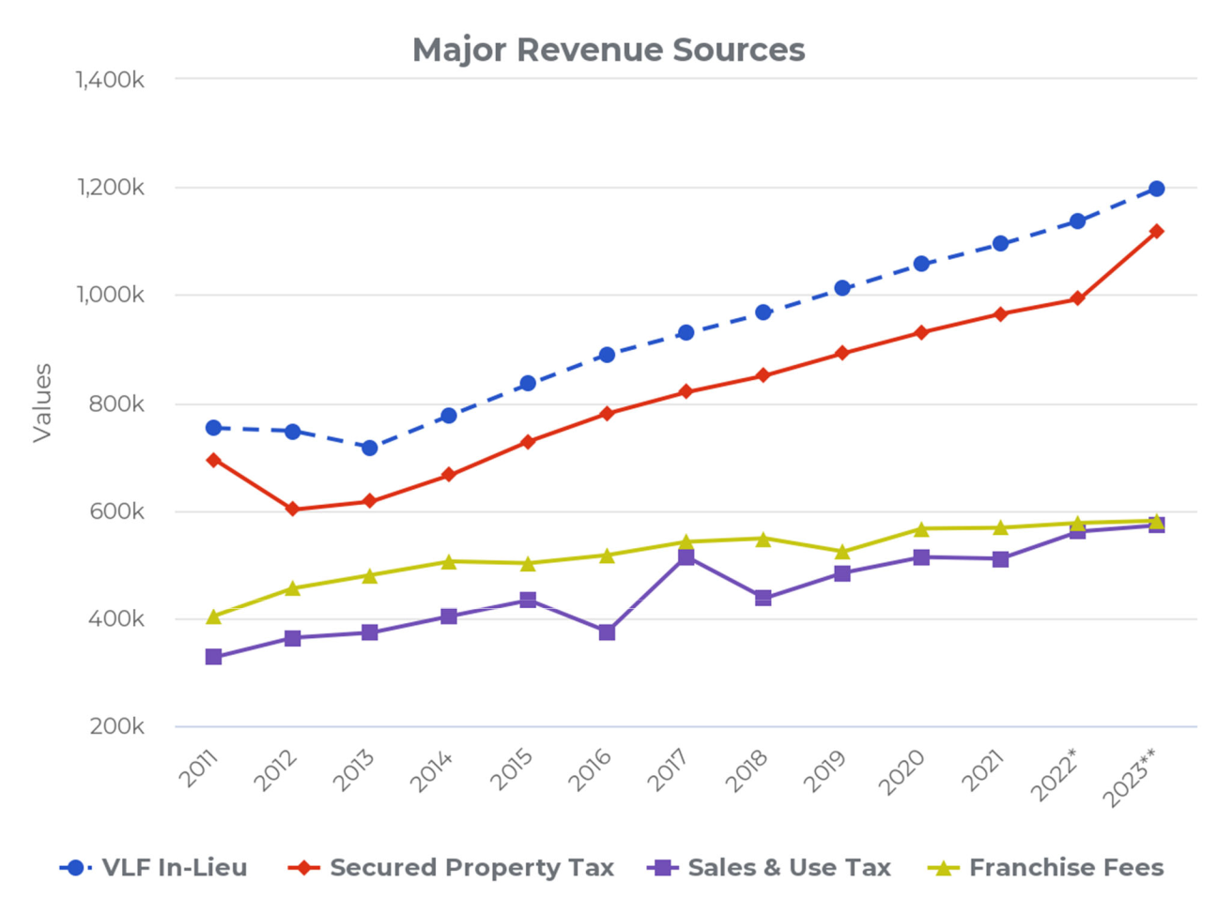

6

City of Clayton

Comprehensive Annual Financial Report
For the year ended June 30, 2022
Letter of Transmittal

Altogether, these four primary revenue sources (Property Tax In-Lieu 22.1%, Property Taxes 20.6%, Franchise Fees 10.7%, Sales and Use Taxes 10.5%) comprise 63.9% of General Fund revenues per the adopted budget for the fiscal year ending June 30, 2023. A non-recurring spike was realized in sales and use taxes six years ago in the year ended June 30, 2017 attributable to the City receiving a final true-up Triple Flip allocation from the state following the statutory dissolution of this process effective January 1, 2017. Accordingly, the following year realized a dip back to “normal” sales & use tax trend levels. In the long-run however, given the suburban composition of the City and its geographic boundaries limiting future development, management anticipates slow growth for the next ten years in sales & use taxes and franchise fees and moderate growth in property tax revenue (including in-lieu VLF property taxes received from the state) . With increasing telecommunications technologies, cable-based franchise fees could be a declining or at-risk revenue, while other factors such as weather patterns and sustainable energy trends could impact similar franchise fee revenue. Given the recent U.S. Supreme Court South Dakota v. Wayfair ruling, it is reasonably possible the City will see an increase in sales & use tax revenue in forthcoming years with the definition of eligible taxable sales transactions now potentially including all online sales where “substantial nexus” requirements exist with online sellers in California.

Long‐Term Financial Planning

As of the year ended June 30, 2022, the City of Clayton’s financial condition remains sound. An indicator of financial condition is the level of fund balances, both reserved and unreserved, in the City’s General Fund. The City Council has directed an absolute minimum reserve of $250,000 as its never-to-be-expended “catastrophic reserve.” In practice, due to the effectiveness in fiscal management, this policy has been easily achieved, indicating perhaps this floor requirement should be elevated in the future. However, the standing Policy Goal of the City Council is to establish and retain an undesignated reserve of 50% the annual General Fund operating budget. At June 30, 2022, the total unassigned General Fund reserve balance is $6,068,266 or .97 times the size of the adopted General Fund operating budget for the fiscal year ending June 30, 2022. This means in an emergency scenario, the City could operate over an entire year on reserves alone.

The City of Clayton maintains a five-year Capital Improvement Program (CIP), which serves as its planning document to ensure its infrastructure is well maintained. The City prioritizes roads for maintenance and reconstruction based on the relative pavement condition index, with other infrastructure and facility improvement projects prioritized at the discretion of the City Council. Over the course of the last 10 years the City has invested approximately $1.0 million into facility and infrastructure capital improvements, funded by Highway User Tax Apportionments (i.e. HUTA or “gas taxes”), local Measure J taxes, redevelopment property tax increment allocations (prior to the dissolution of the Clayton Redevelopment Agency in 2012), and other state and federal grants. For the upcoming fiscal year ending June 30, 2023, the City’s CIP is expected to invest an additional $1,362,697 into transportation and general infrastructure maintenance and improvement needs of the community.

7

City of Clayton

Comprehensive Annual Financial Report
For the year ended June 30, 2022
Letter of Transmittal

Acknowledgements

The preparation of an ACFR cannot be accomplished without the professional, efficient and dedicated services of the Admin/Finance/Legal Department staff (in particular, Accounting Technician Jennifer Giantvalley), and the independent accounting firm of Cropper Rowe, LLP. We also thank the honorable members of the City Council and the various departments for their cooperation and support in planning and conducting the financial operations of the City during the fiscal year.

Respectfully Submitted,

Reina J. Schwartz Nitish Sharma

City Manager Finance Director (Interim)

8

OUR MISSION

To be of exemplary service to the Clayton community with an emphasis on:

- Health and safety

- Responsive customer service

- Highly trained team of employees

- A cooperative work environment

OUR VALUES

➢ Courtesy ➢ Inclusiveness

➢ Creativity ➢ Informed risk taking
➢ Diversity ➢ Open communication
➢ Employee participation ➢ Professionalism
➢ Ethical behavior ➢ Trustworthiness
➢ Fiscal responsibility

OUR VISION

The City of Clayton organization will be recognized as a premier small city. Customer service will be our hallmark; organizational processes will be a model of efficiency and effectiveness; innovation will be common place; and excellence of work product will be the norm. The employees will enjoy their work environment, and each will be a valued and respected member in his or her field of work. All residents and the City Council will be proud of their City government.

9

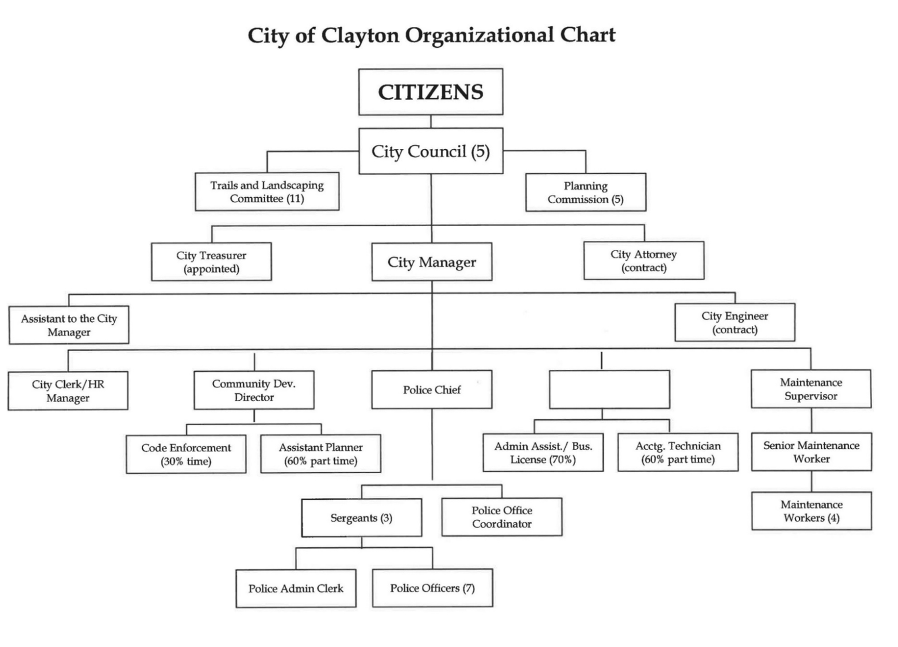

Finance Director

10

DIRECTORY OF PRINCIPAL OFFICIALS AND ADVISORY BODIES

As of report issuance

CITY COUNCIL

Jeff Wan, Mayor

Jim Diaz, Vice Mayor
Peter Cloven, Councilmember
Holly Tillman, Councilmember
Kim Trupiano, Councilmember

COMMISSIONS

Planning Commission

COMMITTEES

Trails and Landscaping Committee

APPOINTED OFFICIALS AND DEPARTMENT HEADS

Reina Schwartz |  | City Manager
Hank Stratford |  | City Treasurer
Nitish Sharma |  | Finance Director (Interim)
Richard McEachin |  | Chief of Police
Janet Calderon |  | City Clerk / HR Manager
Dana Ayers |  | Community Development Director
Jim Warburton |  | Maintenance Supervisor
Malathy Subramanian |  | City Attorney (contract)
Larry Theis |  | City Engineer (contract)
 | FINANCE TEAM
Jennifer Giantvalley |  | Accounting Technician
Richard Sanders |  | Accountant (consultant)

11

Regional Map of Clayton, California

And Nearby Cities
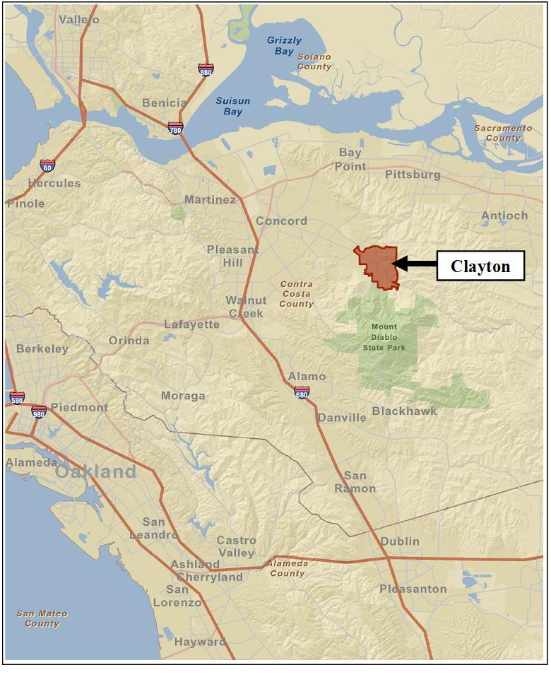

12

This page intentionally left blank

13

FINANCIAL SECTION

14

This page intentionally left blank

15

INDEPENDENT AUDITORS’

REPORT

16



INDEPENDENT AUDITOR’S REPORT

To the City Council

City of Clayton, California

Report on the Audit of the Financial Statements

Opinions

We have audited the accompanying financial statements of the governmental activities, the business-type activities, each major fund, and the aggregate remaining fund information of the City of Clayton, Clayton, as of and for the year ended June 30, 2022, and the related notes to the financial statements, which collectively comprise the City of Clayton’s basic financial statements as listed in the table of contents.

In our opinion, the financial statements referred to above present fairly, in all material respects, the respective financial position of the governmental activities, the business-type activities, each major fund, and the aggregate remaining fund information of the City of Clayton, as of June 30, 2022, and the respective changes in financial position, and, where applicable, cash flows thereof for the year then ended in accordance with accounting principles generally accepted in the United States of America.

Basis for Opinions

We conducted our audit in accordance with auditing standards generally accepted in the United States of America and the standards applicable to financial audits contained in Government Auditing Standards, issued by the Comptroller General of the United States. Our responsibilities under those standards are further described in the Auditor’s Responsibilities for the Audit of the Financial Statements section of our report. We are required to be independent of the City of Clayton and to meet our other ethical responsibilities, in accordance with the relevant ethical requirements relating to our audit. We believe that the audit evidence we have obtained is sufficient and appropriate to provide a basis for our audit opinions.

Responsibilities of Management for the Financial Statements

Management is responsible for the preparation and fair presentation of the financial statements in accordance with accounting principles generally accepted in the United States of America, and for the design, implementation, and maintenance of internal control relevant to the preparation and fair presentation of financial statements that are free from material misstatement, whether due to fraud or error.

In preparing the financial statements, management is required to evaluate whether there are conditions or events, considered in the aggregate, that raise substantial doubt about the City of Clayton’s ability to continue as a going concern for twelve months beyond the financial statement date, including any currently known information that may raise substantial doubt shortly thereafter.

Auditor’s Responsibilities for the Audit of the Financial Statements

Our objectives are to obtain reasonable assurance about whether the financial statements as a whole are free from material misstatement, whether due to fraud or error, and to issue an auditor’s report that includes our opinions. Reasonable assurance is a high level of assurance but is not absolute assurance and therefore is not a guarantee that an audit conducted in accordance with generally accepted auditing standards and Government Auditing Standards will always detect a material misstatement when it exists. The risk of not detecting a material misstatement resulting from fraud is higher than for one resulting

17

from error, as fraud may involve collusion, forgery, intentional omissions, misrepresentations, or the override of internal control. Misstatements are considered material if there is a substantial likelihood that, individually or in the aggregate, they would influence the judgment made by a reasonable user based on the financial statements.

In performing an audit in accordance with generally accepted auditing standards and Government Auditing Standards, we:

Exercise professional judgment and maintain professional skepticism throughout the audit.

Identify and assess the risks of material misstatement of the financial statements, whether due to fraud or error, and design and perform audit procedures responsive to those risks. Such procedures include examining, on a test basis, evidence regarding the amounts and disclosures in the financial statements.

Obtain an understanding of internal control relevant to the audit in order to design audit procedures that are appropriate in the circumstances, but not for the purpose of expressing an opinion on the effectiveness of the City of Clayton’s internal control. Accordingly, no such opinion is expressed.

Evaluate the appropriateness of accounting policies used and the reasonableness of significant accounting estimates made by management, as well as evaluate the overall presentation of the financial statements.

Conclude whether, in our judgment, there are conditions or events, considered in the aggregate, that raise substantial doubt about the City of Clayton’s ability to continue as a going concern for a reasonable period of time.

We are required to communicate with those charged with governance regarding, among other matters, the planned scope and timing of the audit, significant audit findings, and certain internal control-related matters that we identified during the audit.

Required Supplementary Information

Accounting principles generally accepted in the United States of America require that the management’s discussion and analysis, pension plan funding status, other postemployment benefits plan funding status, and budgetary comparison information on pages 21-31 and 103-111 be presented to supplement the basic financial statements. Such information is the responsibility of management and, although not a part of the basic financial statements, is required by the Governmental Accounting Standards Board who considers it to be an essential part of financial reporting for placing the basic financial statements in an appropriate operational, economic, or historical context. We have applied certain limited procedures to the required supplementary information in accordance with auditing standards generally accepted in the United States of America, which consisted of inquiries of management about the methods of preparing the information and comparing the information for consistency with management’s responses to our inquiries, the basic financial statements, and other knowledge we obtained during our audit of the basic financial statements. We do not express an opinion or provide any assurance on the information because the limited procedures do not provide us with sufficient evidence to express an opinion or provide any assurance.

Supplementary Information

Our audit was conducted for the purpose of forming opinions on the financial statements that collectively comprise the City of Clayton’s basic financial statements. The accompanying combining and individual nonmajor fund financial statements are presented for purposes of additional analysis and

18

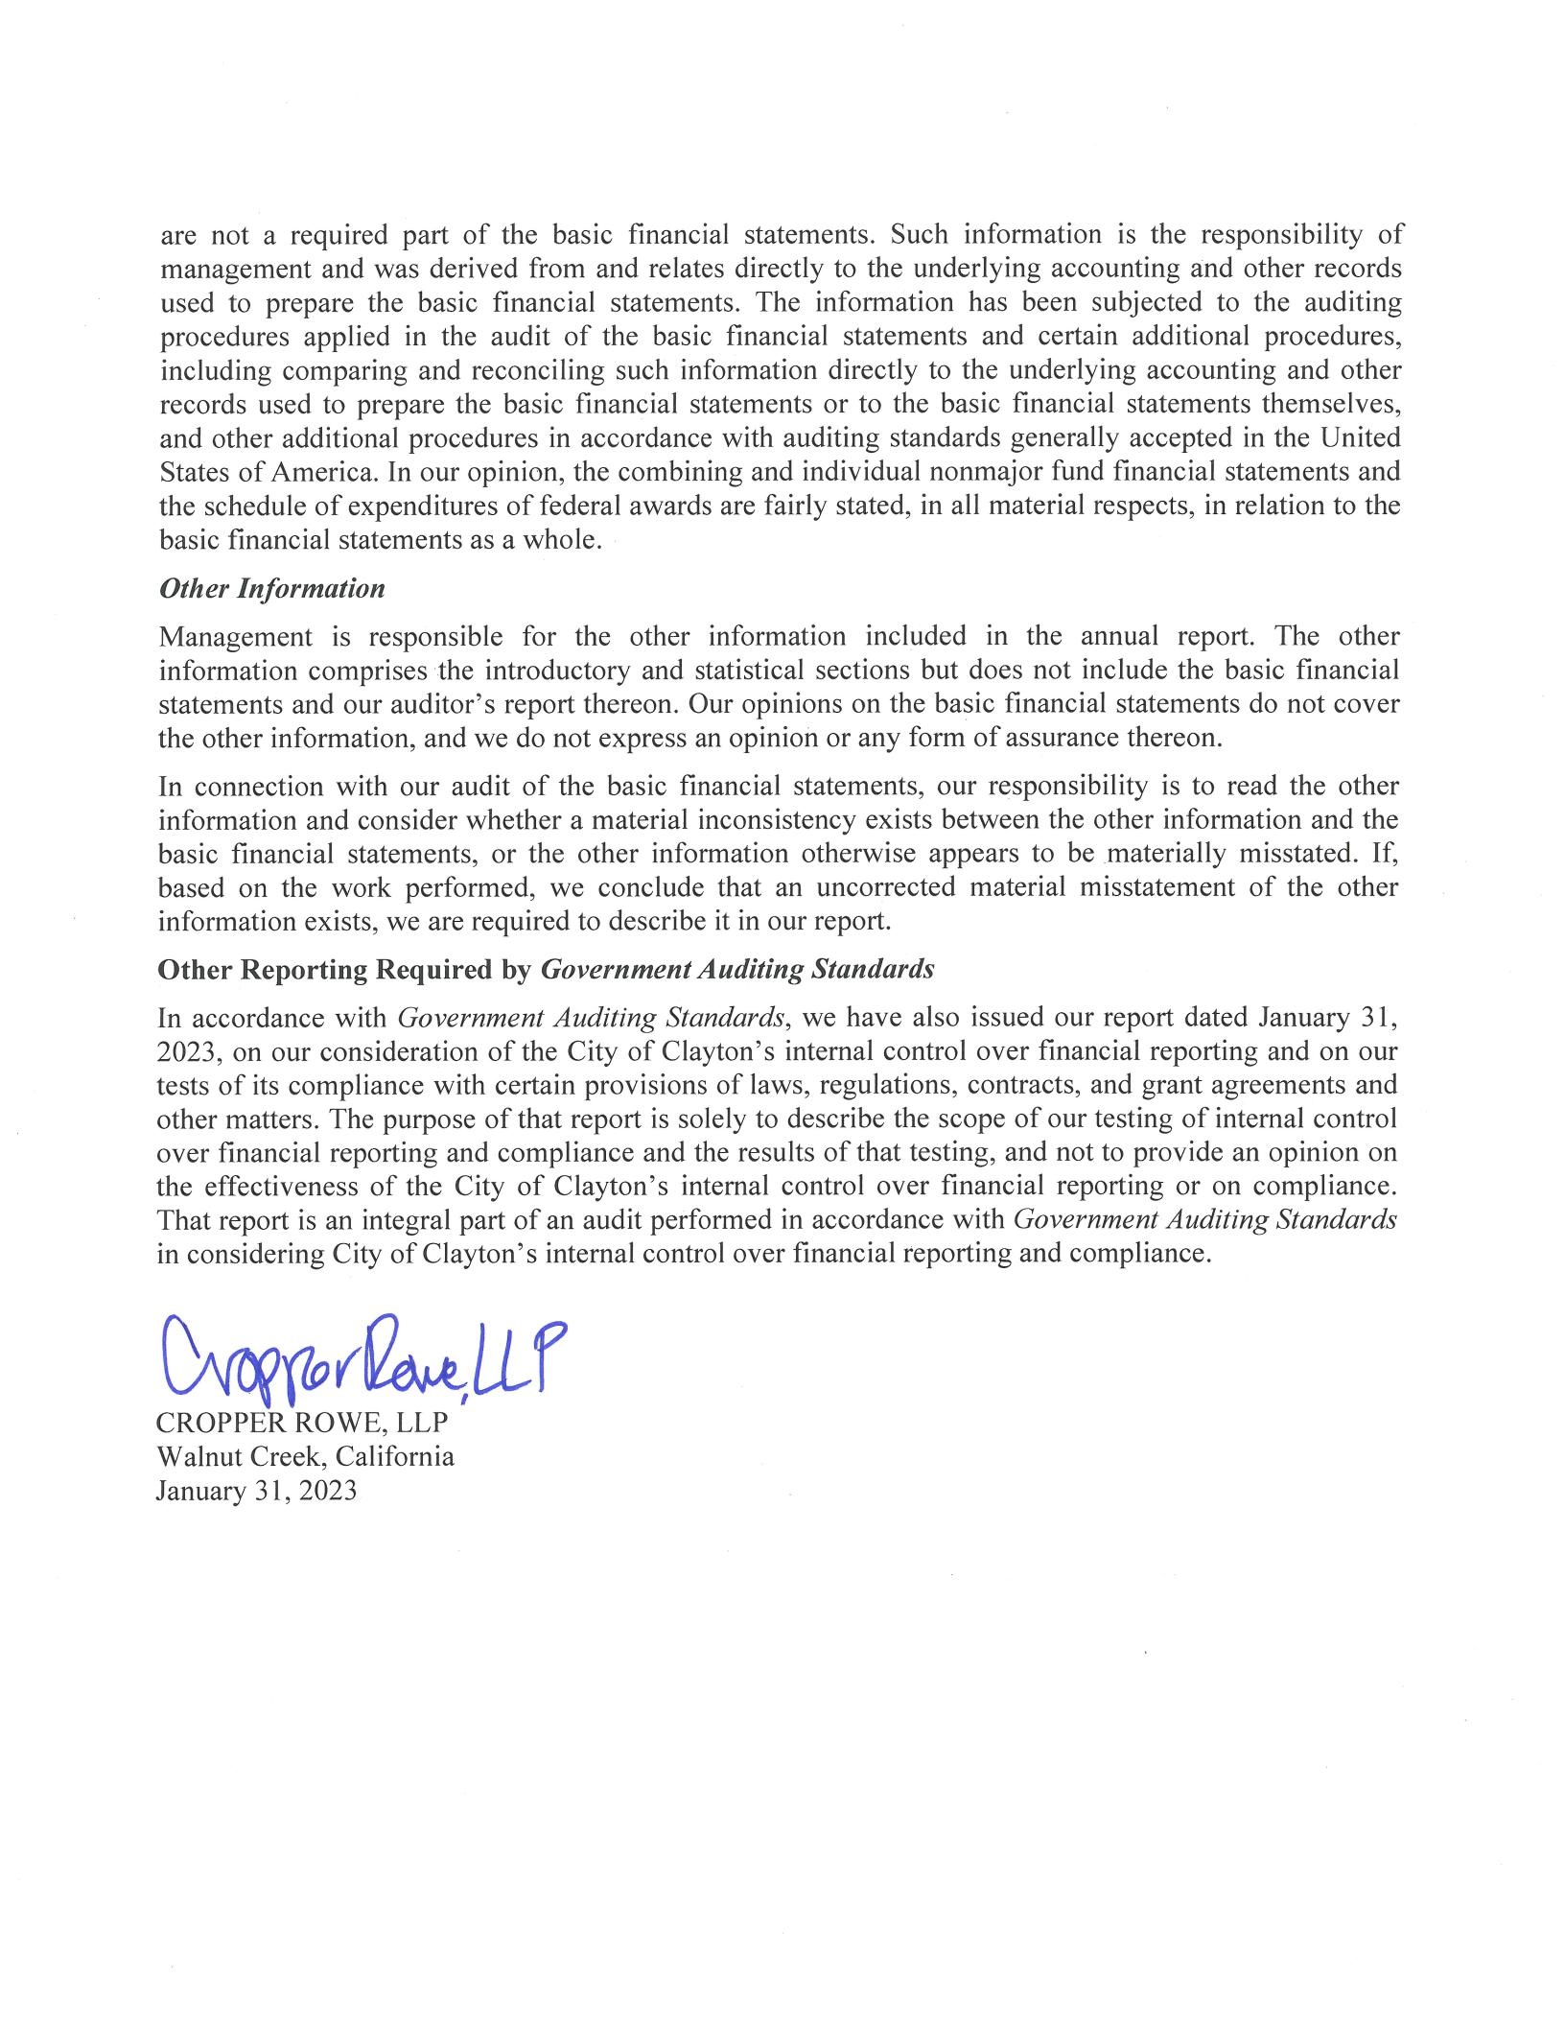

19

MANAGEMENT’S DISCUSSION AND ANALYSIS

20

Management of the City of Clayton (the "City") provides this Management’s Discussion and Analysis of the City's Basic Financial Statements for readers of the City's financial statements. This narrative overview and analysis of the financial activities of the City is for its fiscal year ended June 30, 2022. We encourage readers to consider this information in conjunction with the additional information that is furnished with the City's financial statements, which follow.

FINANCIAL HIGHLIGHTS - PRIMARY GOVERNMENT Government -Wide Highlights

Net Position - The assets of the City of Clayton exceeded its liabilities at the close of the year ended June 30, 2022, by $45,759,874. Of this amount, $5,744,418 was reported as "unrestricted net position" and may be used to meet the ongoing obligations to citizens and creditors.

Changes in Net Position - The City's total net position increased by $337,870 in the fiscal year ending June 30, 2022. Net position of governmental activities increased by $381,717, while net position of business-type activities decreased by $43,847.

Major Fund Highlights

Governmental Funds – As of the year ended June 30, 2022, the City's governmental funds reported a combined ending fund balance of $17,172,907. Of this amount $5,744,867 represents "unassigned fund balances" available for appropriation.

General Fund - The unassigned fund balance of the General Fund on June 30, 2022 was $5,744,867, while the non-spendable and committed fund balances were $173,471 and $495,019 respectively.

OVERVIEW OF THE FINANCIAL STATEMENTS

This discussion and analysis is intended to serve as an introduction to the City of Clayton's basic financial statements. The City of Clayton's basic financial statements comprise three components: 1) government-wide financial statements, 2) fund financial statements and 3) notes to the financial statements. This report also contains required supplementary information and supplemental information in addition to the basic financial statements themselves.

Government-wide Financial Statements

The government-wide financial statements are designed to provide readers with a broad overview of the City of Clayton's finances, in a manner similar to a private-sector business.

The statement of net position presents information on all of the City of Clayton's assets and liabilities, with the difference between the two reported as net position. Over time, increases or decreases in net position may serve as a useful indicator of whether the financial position of the City of Clayton is improving or deteriorating.

21

OVERVIEW OF THE FINANCIAL STATEMENTS, Continued Government-wide Financial Statements, Continued

The statement of activities presents information showing how the City's net position changed during the most recent fiscal year. All changes in net position are reported as soon as the underlying event giving rise to the change occurs, regardless of the timing of related cash flows. Thus, revenues and expenses are reported in this statement for some items that will only result in cash flows in future fiscal periods (e. g. uncollected taxes and earned but unused vacation leave).

Both of the government-wide financial statements distinguish functions of the City of Clayton that are principally supported by taxes and intergovernmental revenues (governmental activities) from other functions that are intended to recover all or a significant portion of their costs through user fees and charges (business-type activities). The governmental activities of the City of Clayton include general government, public safety, public works, community and economic development, and parks and recreation services. The business-type activities of the City of Clayton include the activities of the Endeavor Hall enterprise fund.

Fund Financial Statements

A fund is a grouping of related accounts that is used to maintain control over resources that have been segregated for specific activities or objectives. The City of Clayton, like other state and local governments, uses fund accounting to ensure and demonstrate compliance with finance-related legal requirements. All of the funds of the City of Clayton can be divided into three categories: governmental funds, proprietary funds, and fiduciary funds.

Governmental Funds

Governmental funds are used to account for essentially the same functions reported as governmental activities in the government-wide financial statements. However, unlike the government-wide financial statements, governmental fund financial statements focus on near-term inflows and outflows of spendable resources, as well as on balances of spendable resources available at the end of the fiscal year. Such information may be useful in evaluating a government's near-term financing requirements.

Because the focus of governmental funds is narrower than that of the government-wide financial statements, it is useful to compare the information presented for governmental funds with similar information presented for governmental activities in the government- wide financial statements. By doing so, readers may better understand the long- term impact of the government's near-term financing decisions. Both the governmental fund balance sheet and the governmental fund statement of revenues, expenditures, and changes in fund balances provide a reconciliation to facilitate this comparison between governmental funds and governmental activities.

22

OVERVIEW OF THE FINANCIAL STATEMENTS, Continued Fund Financial Statements, Continued

The City of Clayton maintains fifteen individual governmental funds. Information is presented separately in the government funds balance sheet and governmental funds statement of revenues, expenditures, and changes in fund balances for the General Fund, Landscape Maintenance District, Housing Successor Agency, and Capital Improvement Program, all of which are reported as major funds.

Proprietary Funds

The City of Clayton maintains two different types of proprietary funds. Enterprise funds are used to report the same functions presented as business-type activities in the government- wide financial statements. The City of Clayton uses an enterprise fund to account for its Endeavor Hall activities. Internal service funds are an accounting device used to accumulate and allocate costs internally among the City of Clayton various functions. City of Clayton uses three internal service funds to account for its capital equipment replacement program, self-insurance activities, and extraordinary employer pension contribution fluctuations. Because these services predominantly benefit governmental rather that business-type functions, they have been included within governmental activities in the government-wide financial statements.

Proprietary funds provide the same type of information as the government-wide financial statements, only in more detail. The City’s sole enterprise fund is considered to be a major fund. The internal service funds are combined into a single, aggregated presentation in the proprietary fund financial statements.

Fiduciary Funds

The City is the fiscal agent for benefit assessment districts and other parties holding amounts collected which await payment as directed. The City’s fiduciary activities are reported in the separate statement of fiduciary net position and the agency funds statement of assets and liabilities. These activities are excluded from the City’s other financial statements because the City is acting as a trustee for these funds and cannot use these assets to finance its own operations. The City’s fiduciary funds include a private-purpose trust fund to account for the activities of the City of Clayton Redevelopment Successor Agency.

Notes to the Financial Statements

The notes provide additional information that is essential to a full understanding of the data provided in the government -wide and fund financial statements. The notes to the financial statements can be found on pages 55-101 of this report.

23

OVERVIEW OF THE FINANCIAL STATEMENTS, Continued Other Information

In addition to the basic financial statements and accompanying notes, this report also presents certain required supplementary information concerning the City’s progress in funding its obligation to provide pension and other post -employment benefits to its employees as well as budgetary information for the General Fund and each of the major governmental funds.

FINANCIAL ANALYSIS GOVERNMENT-WIDE STATEMENTS Analysis of Overall Net Position and Results of Operations

As noted previously, net position may serve over time as a useful indicator of a government's financial position. The City’s total net position was $45,759,874 at June 30, 2022, which is an increase of $392,782 from the prior year’s restated net position at June 30, 2021.

The largest portion of the City’s net position reflects its investment in capital assets (e. g. land, buildings, etc. ) net of any related debt used to acquire those assets that is still outstanding. The City uses these capital assets to provide services to citizens and these assets are not available for future spending. Although the City’s investment in its capital assets is reported net of related debt, it should be noted that the resources needed to repay this debt must be provided from other sources, since the capital assets themselves cannot be used to liquidate these liabilities. The following is condensed comparative Statements of Net Position for the fiscal years ended June 30, 2022 and June 30, 2021:

 |  |  |  |  |  |  | Business- |  |  |  | Business-
 | Governmental |  |  | Governmental |  |  |  | Type |  |  | Type
 |  | Activities |  |  | Activities |  | Activities |  |  |  | Activities |  |  | Total |  |  | Total
Assets |  | 2022 |  |  | 2021 |  |  | 2022 |  |  | 2021 |  |  | 2022 |  |  | 2021
Current Assets | $ | 14,773,722 |  | $ | 14,812,813 |  | $ | (120,893) |  | $ | (112,174) |  | $ | 14,652,829 |  | $ | 14,700,639
Noncurrent Assets |  | 6,482,003 |  |  | 6,462,021 |  |  | - |  |  | - |  |  | 6,482,003 |  |  | 6,462,021
Capital Assets |  | 29,116,205 |  |  | 28,793,685 |  |  | 1,009,203 |  |  | 1,038,076 |  |  | 30,125,408 |  |  | 29,831,761
Total Assets
 |  | 50,371,930 |  |  | 50,068,519 |  |  | 888,310 |  |  | 925,902 |  |  | 51,260,240 |  |  | 50,994,421
Deferred outflows |  | 1,285,641 |  |  | 1,051,589 |  |  | - |  |  | - |  |  | 1,285,641 |  |  | 1,051,589
Liabilities
Current Liabilities |  | 640,113 |  |  | 362,937 |  |  | 8,171 |  |  | 1,916 |  |  | 648,284 |  |  | 364,853
Noncurrent Liabilities |  | 3,666,339 |  |  | 5,944,104 |  |  | - |  |  | - |  |  | 3,666,339 |  |  | 5,944,104
Total Liabilities
 |  | 4,306,452 |  |  | 6,307,041 |  |  | 8,171 |  |  | 1,916 |  |  | 4,314,623 |  |  | 6,308,957
Deferred inflows |  | 2,471,384 |  |  | 369,961 |  |  | - |  |  | - |  |  | 2,471,384 |  |  | 369,961
Net Position
Net investment in
capital assets |  | 29,116,205 |  |  | 28,793,685 |  |  | 1,009,203 |  |  | 1,038,076 |  |  | 30,125,408 |  |  | 29,831,761
Restricted |  | 9,890,048 |  |  | 13,156,670 |  |  | - |  |  | - |  |  | 9,890,048 |  |  | 13,156,670
Unrestricted |  | 5,873,482 |  |  | 2,492,751 |  |  | (129,064) |  |  | (114,090) |  |  | 5,744,418 |  |  | 2,378,661
Total net position
 | $ | 44,879,735 |  | $ | 44,443,106 |  | $ | 880,139 |  | $ | 923,986 |  | $ | 45,759,874 |  | $ | 45,367,092

24

FINANCIAL ANALYSIS GOVERNMENT-WIDE STATEMENTS, Continued Analysis of Overall Net Position and Results of Operations, Continued

Of the City’s total net position, $9,890,048 (21.6%) represents resources that are subject to external restrictions on how they may be used. The balance of the unrestricted net position of $5,744,418 (12.6%) may be used to meet the City's ongoing obligations to citizens and creditors. City revenues for the year, including both governmental and business-type activities, were $9,359,704, while expenses totaled $9,021,834, resulting in a net increase in net position of $337,870 excluding transfers, extraordinary and special items. This net increase was primarily attributable to a increase in net position of governmental activities, which is discussed in greater detail in the following section.

The following is a recap of the City’s Statement of Activities and Changes in Net Position for the fiscal years ended June 30, 2022 and June 30, 2021:

 |  |  |  |  |  |  |  |  | Business- |  |  | Business-
 | Governmental |  |  | Governmental |  |  |  |  | Type |  |  | Type
 |  | Activities |  |  |  | Activities |  |  | Activities |  |  | Activities |  |  | Total |  |  | Total
Revenues: |  | 2022 |  |  |  | 2021 |  |  | 2022 |  |  | 2021 |  |  | 2022 |  |  | 2021
Program revenues:
Charges for Services | $ | 1,002,338 |  | $ |  | 961,910 |  | $ | 16,847 |  | $ | (1,442) |  | $ | 1,019,185 |  | $ | 960,468
Operating grants and contributions |  | 2,755,382 |  |  |  | 893,718 |  |  | - |  |  | - |  |  | 2,755,382 |  |  | 893,718
Capital grants and contributions |  | 120,774 |  |  |  | 42,363 |  |  | - |  |  | - |  |  | 120,774 |  |  | 42,363
Total program revenues
 |  | 3,878,494 |  |  |  | 1,897,991 |  |  | 16,847 |  |  | (1,442) |  |  | 3,895,341 |  |  | 1,896,549
General revenues:
Property taxes |  | 2,846,766 |  |  |  | 2,722,906 |  |  | - |  |  | - |  |  | 2,846,766 |  |  | 2,722,906
Special parcel taxes |  | 1,348,657 |  |  |  | 1,309,373 |  |  | - |  |  | - |  |  | 1,348,657 |  |  | 1,309,373
Sales and use taxes |  | 563,908 |  |  |  | 510,029 |  |  | - |  |  | - |  |  | 563,908 |  |  | 510,029
Business license taxes |  | 162,881 |  |  |  | 90,872 |  |  | - |  |  | - |  |  | 162,881 |  |  | 90,872
Franchise fees |  | 587,740 |  |  |  | 567,350 |  |  | - |  |  | - |  |  | 587,740 |  |  | 567,350
Payments in lieu of taxes |  | 174,443 |  |  |  | 171,029 |  |  | - |  |  | - |  |  | 174,443 |  |  | 171,029
Investment income |  | (281,502) |  |  |  | 508,256 |  |  |  |  |  | (379) |  |  | (281,502) |  |  | 507,877
Miscellaneous |  | 54,512 |  |  |  | 38,972 |  |  | - |  |  | - |  |  | 54,512 |  |  | 38,972
Gain (loss) on sale of assets |  | 6,958 |  |  |  | 1,741 |  |  | - |  |  | - |  |  | 6,958 |  |  | 1,741
Total general revenues
 |  | 5,464,363 |  |  |  | 5,920,528 |  |  |  |  |  | (379) |  |  | 5,464,363 |  |  | 5,920,149
Total revenues
 |  | 9,342,857 |  |  |  | 7,818,519 |  |  | 16,847 |  |  | (1,821) |  |  | 9,359,704 |  |  | 7,816,698
Expenses:
General government |  | 2,629,048 |  |  |  | 1,796,454 |  |  | - |  |  | - |  |  | 2,629,048 |  |  | 1,796,454
Public works |  | 2,509,096 |  |  |  | 2,909,710 |  |  | - |  |  | - |  |  | 2,509,096 |  |  | 2,909,710
Public safety |  | 2,736,817 |  |  |  | 2,980,000 |  |  | - |  |  | - |  |  | 2,736,817 |  |  | 2,980,000
Community and economic
development |  | 356,450 |  |  |  | 357,133 |  |  | - |  |  | - |  |  | 356,450 |  |  | 357,133
Parks and recreation services |  | 729,729 |  |  |  | 592,433 |  |  | - |  |  | - |  |  | 729,729 |  |  | 592,433
Endeavor Hall |  | - |  |  |  | - |  |  | 60,694 |  |  | 73,117 |  |  | 60,694 |  |  | 73,117
Total expenses
 |  | 8,961,140 |  |  |  | 8,635,730 |  |  | 60,694 |  |  | 73,117 |  |  | 9,021,834 |  |  | 8,708,847
Change in Net Position |  | 381,717 |  |  |  | (817,211) |  |  | (43,847) |  |  | (74,938) |  |  | 337,870 |  |  | (892,149)
Net Position – Beginning, restated
 |  | 44,498,018 |  |  |  | 45,260,317 |  |  | 923,986 |  |  | 998,924 |  |  | 45,422,004 |  |  | 46,259,241
Net Position – ending
 | $ | 44,879,735 |  |  | $ | 44,443,106 |  | $ | 880,139 |  | $ | 923,986 |  | $ | 45,759,874 |  | $ | 45,367,092

25

FINANCIAL ANALYSIS GOVERNMENT-WIDE STATEMENTS, Continued Analysis of Governmental Activities

The increase in net position of the governmental activities over the prior year was primarily attributable to a increase in both operating and capital grants and contributions. Total expenses were $8,961,140 in the current year compared to $8,635,730 in the prior year. The following chart depicts the relative size of expenses by function for the fiscal years ending June 30, 2022 and 2021:
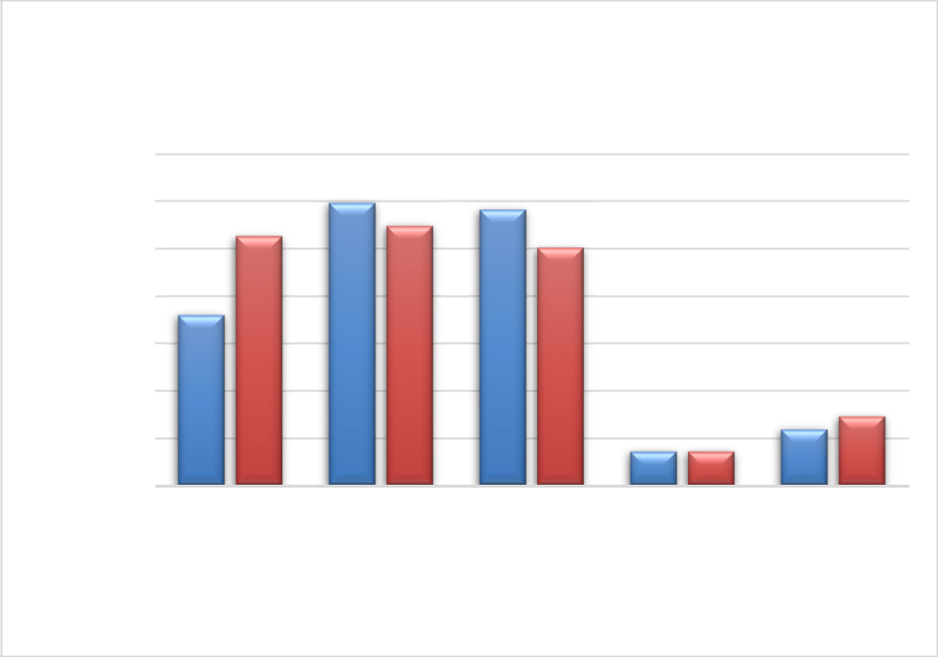

Government Activities

Expenses by Function

3,500,000

3,000,000

2,500,000

2,000,000

1,500,000

1,000,000

500,000

-

General
Government

Public Safety

Public Works Community Parks and
and Economic Recreation

Development Services

Fiscal Year 2021

Fiscal Year 2022

Total program revenues from governmental activities were $ 3,878,494 in the current year compared to $1,897,991 in the prior year. Program revenues are derived directly from the program itself or from parties outside the reporting government's taxpayers or citizenry. They reduce the net cost of the function to be financed from government's general revenues. Of the governmental program revenues, 25.8% were derived from charges for services, which includes park use fees, rental fees, licenses and permits, planning services fees, engineering plan check fees, police service fees, and other revenues. The remaining 74.2% of the governmental program revenues came from operating and capital grants and contributions. General revenues are all other revenues not categorized as program revenues such as property taxes, special parcel taxes, sales and use taxes, motor vehicle fees, investment earnings, franchise fees, use of money and property, service charges, and miscellaneous revenues.

26

FINANCIAL ANALYSIS GOVERNMENT-WIDE STATEMENTS, Continued Analysis of Governmental Activities, Continued
Total general revenues from governmental activities decreased by $456,165 (7.7%) over the prior year. The following pie charts depict the relative size of governmental activities program and general revenues by source for the fiscal years ending June 30, 2022 and 2021:
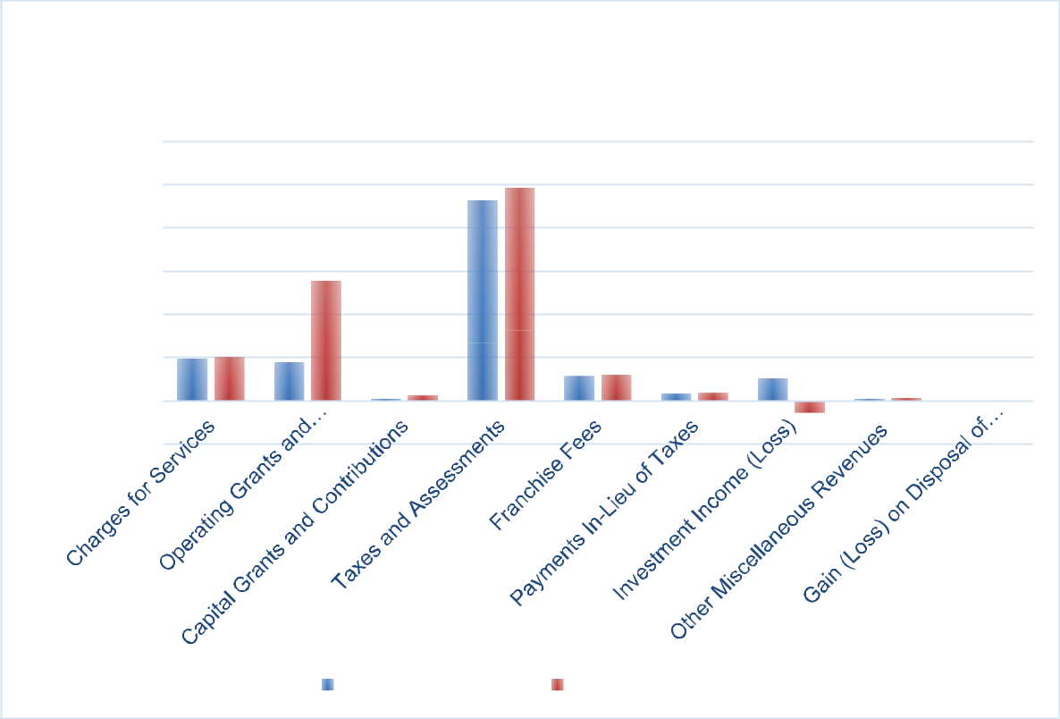

Governmental Activities
Revenues by Source
$6,000,000
$5,000,000
$4,000,000
$3,000,000
$2,000,000
$1,000,000
$-
$(1,000,000)
Fiscal Year 2021 | Fiscal Year 2022

Analysis of Business-Type Activities

Total business-type expenses decreased 20.4% from $73,117 in the prior year to $60,694 in the current year. This decrease is largely attributable to the decrease in general and administrative costs of the Endeavor Hall rental facility. Total services revenue increased significantly from $-1,442 in the prior year to $16,847 in the current year due to the increase in rental activity. Net position of business -type activities declined $43,847 to a total of $ 880,139 at June 30, 2022 due to charges for services being insufficient to cover the annual depreciation expense and general operating expenses of underlying Endeavor Hall rental facility assets.

27

FINANCIAL ANALYSIS OF INDIVIDUAL FUND STATEMENTS Analysis of Governmental Funds

The focus of the City of Clayton's governmental funds is to provide information on near-term inflows, outflows, and balances of spendable resources. Such information is useful in assessing the City of Clayton's financing requirements. In particular, unassigned fund balance may serve as a useful measure of a government's net resources available for spending at the end of the fiscal year.

As of the end of the current fiscal year, the City’s governmental funds reported combined ending fund balances of $17,172,907. Of this amount, $5,744,867 (33.5%) is unassigned; $173,471(1.0%) is in non-spendable form; $3,330,153 (19.4%) is assigned for specific purposes; $6,719,595 (39.1%) is restricted by law, regulation, or other outside contractual agreements; and $1,204,821 (7.0%) is committed for specific expenditures in the future.

General Fund

The City’s General Fund reported an increase in fund balance of $249,464 (4.0%) in the current fiscal year. This modest increase is mostly attributable to increase in property taxes, special parcel taxes and assessments, and a corresponding decrease in investment earnings (primarily due to market rate adjustments). Total fund balance of the General Fund is $6,413,357 as of June 30, 2022, of which $5,744,867 (89.6%) is reported as unassigned and available for appropriation. This unassigned fund balance is .92 times the size of the General Fund’s adopted operating budget for the upcoming fiscal year ending June 30, 2022.

Below is a summary of the General Fund expenditures by department.

 |  |  |  |  |  |  |  | Pandemic
 |  |  |  |  | Rainy |  |  | Recovery
General government | General Fund |  |  |  | Day Fund |  |  | Reserve |  |  | Total
 | $ | 1,447,700 |  | $ | 26,000 |  | $ | 1,096,717 |  | $ | 2,570,417
Public safety |  | 2,684,319 |  |  | - |  |  | - |  |  | 2,684,319
Public works |  | 333,423 |  |  | - |  |  | - |  |  | 333,423
Community and
economic development |  | 299,175 |  |  | - |  |  | - |  |  | 299,175
Parks and recreation
services |  | 336,592 |  |  | - |  |  | - |  |  | 336,592
Capital outlay |  | 22,168 |  |  | - |  |  | - |  |  | 22,168
Total expenditures | $ | 5,123,377 |  | $ | 26,000 |  | $ | 1,096,717 |  | $ | 6,246,094

Landscape Maintenance District

Community Facilities District No. 2007-1, referred to as the Landscape Maintenance District special revenue fund, reported a decrease in fund balance of $447,353 (41.2%) in the current fiscal year. This decrease in fund balance is largely attributable to increases in operating costs such as water service and weed abatement, as well as a increase in project costs/capital outlay costs. Total fund balance of the Landscape Maintenance District is $ 638,533 as of June 30, 2022, of which $ 32,509 is reported as assigned or restricted for the following year’s operating budget, and the remaining fund balance is assigned.

28

FINANCIAL ANALYSIS OF INDIVIDUAL FUND STATEMENTS, Continued Analysis of Governmental Funds, Continued
Successor Housing Agency

The Successor Housing Agency special revenue fund reported a increase in fund balance of $187,452 (3.4%) in the current fiscal year. This increase in fund balance resulted primarily from unspent program revenue on housing loan repayments as well as unrealized gains on the inventory of affordable income housing. Total fund balance of the Successor Housing Agency is $5,617,695 as of June 30, 2022, which is classified entirely as restricted.

Capital Improvement Program

The Capital Improvement Program capital projects fund reported an increase in fund balance of $681,698 (35.4%) in the current fiscal year. This increase in fund balance primarily arose from timing differences between project execution and funding. Total fund balance of the Capital Improvement Program fund is $2,606,444 and is reported entirely as assigned for capital projects as of June 30, 2022.

Analysis of Proprietary Funds

The City of Clayton's proprietary funds provide the same type of information found in the government-wide financial statements, but in more detail. The net position of the City’s only major enterprise fund, Endeavor Hall, at the end of the year was $880,139, and total net position for the internal service funds amounted to $1,000,736.

GENERAL FUND BUDGETARY HIGHLIGHTS

General Fund actual revenues and transfers fall short of total revenues and transfers of the final and adopted budget by $39,744. The variance is due to a combination of factors including an increase in taxes and assessment and a decrease in the investment reported at year-end based on the market rate. The unrealized investment loss was reported as a direct result of the City’s investment portfolio being largely made up of fixed instrument securities during a time of declining interest rates. As noted in recent quarterly investment portfolio reports presented to the City Council, the City’s investment policy is designed to reduce volatility and generate consistent returns in the long run-in order to protect public funds. Actual property tax revenues exceeded somewhat conservative adopted budgetary growth projections by $186,163 (6.9%), which was largely offset by lower-than-expected revenue from permits, licenses and fees and sales tax receipts.

29

GENERAL FUND BUDGETARY HIGHLIGHTS, Continued

Actual General Fund expenditures of $6,246,094 were more than the final adjusted budget by $1,447,307 for the year ended June 30, 2022. The negative variance is a result of actual expenditures being more than budgeted in General government due to investments in the capital expenditures for the fiscal year ended June 30, 2022.

CAPITAL ASSET AND DEBT ADMINISTRATION Capital Assets
The City’s investment in capital assets for its governmental and business-type activities as of June 30, 2022 amounted to $30,125,408 (net of accumulated depreciation). This investment in capital assets includes land, building, improvements, machinery and equipment, park facilities, corporate yard building, and roads. Total depreciation expense on governmental assets totaled $1,048,171, versus $1,080,713 in the prior year. The slight decrease in depreciation is attributable to the completion of significant capital projects during the prior and current fiscal years and capital assets reaching their estimated useful lives. Additional information on the City of Clayton's capital assets can be found in Note 6 of this report.

Debt Administration

The remaining debt of the former Clayton Redevelopment Agency (RDA) of $ 5,835,000 was transferred to the Successor Agency on February 1, 2012 (fiscal year ending June 30, 2012) . The City has no outstanding general obligation debt. The Successor Agency has maintained its "AAA" credit rating (S&P) on outstanding Tax Allocation Bonds. Additional information on the Successor Agency's long-term debt can be found in Note 13 of this report.

ECONOMIC FACTORS AND NEXT YEAR’S BUDGET

As the City of Clayton is largely a residential community the annual General Fund operating budget relies heavily on property taxes to finance annual operating appropriations rather than other sources of revenue larger and more commercially and industrial developed municipalities have access to (i. e. sales and transient occupancy taxes). The City strives to meet the ever evolving needs of local residents and businesses within the constraints of limited and sometimes restrictive revenue sources.

There was an increase in adopted General Fund operating appropriations when compared to the actuals reported as of June 30, 2022, for the upcoming fiscal year ending June 30, 2023 of $641,365 (10.2%) . The increase in appropriations is attributable primarily to labor wage and benefit costs of various City departments and capital improvement costs included as part of the general government. The annual June 2021 to June 2022 consumer price index inflationary factor is 6.8% as published by the U. S. Bureau of Labor and Statistics for the San Francisco-Oakland-Hayward region. In addition, there are projected decreases in the annual CalPERS unfunded accrued liabilities and normal costs, primarily due to Classic Tier employees retiring and new employees being hired in the PEPRA tier. The adopted budget for the fiscal year ending June 30, 2023 projects total General Fund revenues of $6,887,459 an increase of approximately

30

City of Clayton

Management’s Discussion and Analysis
For the year ended June 30, 2022

ECONOMIC FACTORS AND NEXT YEAR’S BUDGET, Continued

$34,920 over the prior year actual. The projected revenue growth reflects continued growth in property tax and sales and use taxes supported by actual results reported in the fiscal year ending June 30, 2022.

REQUEST FOR INFORMATION

This financial report is designed to provide a general overview of the City of Clayton's finances for all those with an interest in the City's finances. Questions concerning any of the information provided in this report, or requests for additional financial information, should be addressed to the Office of the Finance Manager, 6000 Heritage Trail, Clayton, California 94517.

31

GOVERNMENT-WIDE

FINANCIAL STATEMENTS

32

City of Clayton

Government-Wide

Statement of Net Position

June 30, 2022

 | Governmental |  |  | Business-Type
ASSETS |  | Activities |  |  | Activites |  |  | Total
Current Assets:
Cash and investments | $ | 13,441,679 | $ |  | - | $ |  | 13,441,679
Accounts receivable (net of allowances) |  | 1,133,315 |  |  | - |  |  | 1,133,315
Interest receivable |  | 25,257 |  |  | - |  |  | 25,257
Internal balances |  | 120,893 |  |  | (120,893) |  |  | -
Prepaid expenses |  | 52,578 |  |  | - |  |  | 52,578
Total Current Assets |  | 14,773,722 |  |  | (120,893) |  |  | 14,652,829
Noncurrent Assets:
Investment in affordable housing |  | 3,170,453 |  |  | - |  |  | 3,170,453
Notes receivable |  | 3,311,550 |  |  | - |  |  | 3,311,550
Nondepreciable assets |  | 3,133,754 |  |  | 167,738 |  |  | 3,301,492
Depreciable assets, net |  | 25,982,451 |  |  | 841,465 |  |  | 26,823,916
Total Noncurrent Assets |  | 35,598,208 |  |  | 1,009,203 |  |  | 36,607,411
Total Assets |  | 50,371,930 |  |  | 888,310 |  |  | 51,260,240
DEFERRED OUTFLOWS OF RESOURCES
Deferred outflows related to pension |  | 1,285,641 |  |  | - |  |  | 1,285,641
Deferred outflows related to OPEB |  | - |  |  | - |  |  | -
Total Deferred Outflows of Resources |  | 1,285,641 |  |  | - |  |  | 1,285,641
LIABILITIES
Current Liabilites:
Accounts payable |  | 149,907 |  |  | 2,671 |  |  | 152,578
Deposits payable |  | - |  |  | 5,500 |  |  | 5,500
Accrued payroll |  | 37 |  |  | - |  |  | 37
Unearned revenue |  | 332,166 |  |  | - |  |  | 332,166
Compensated absences payable |  | 83,645 |  |  | - |  |  | 83,645
Other liabilities |  | 74,358 |  |  | - |  |  | 74,358
Total Current Liabilities |  | 640,113 |  |  | 8,171 |  |  | 648,284
Noncurrent Liabilites:
Compensated absences payable |  | 83,645 |  |  | - |  |  | 83,645
Net OPEB liability |  | 578,315 |  |  | - |  |  | 578,315
Net pension liability |  | 2,759,739 |  |  | - |  |  | 2,759,739
Lease payable |  | 244,640 |  |  | - |  |  | 244,640
Total Noncurrent Liabilities |  | 3,666,339 |  |  | - |  |  | 3,666,339
Total Liabilities |  | 4,306,452 |  |  | 8,171 |  |  | 4,314,623
DEFERRED INFLOWS OF RESOURCES
Deferred inflows related to pension |  | 2,471,384 |  |  | - |  |  | 2,471,384
Deferred inflows related to OPEB |  | - |  |  | - |  |  | -
Total Deferred Inflows of Resources |  | 2,471,384 |  |  | - |  |  | 2,471,384
NET POSITION
Net investment in capital assets |  | 29,116,205 |  |  | 1,009,203 |  |  | 30,125,408
Restricted for special projects and programs |  | 9,890,048 |  |  | - |  |  | 9,890,048
Unrestricted |  | 5,873,482 |  |  | (129,064) |  |  | 5,744,418
Total Net Position | $ | 44,879,735 |  | $ | 880,139 |  | $ | 45,759,874

The accompanying notes are an integral part of the financial statements

33

City of Clayton

Government-Wide

Statement of Activities and Changes in Net Position

For the year ended June 30, 2022

 |  |  |  |  |  |  |  |  | Operating |  | Capital
 |  |  |  |  |  | Charges |  |  | Grants and |  | Grants and |  | Governmental Business-type
Functions/Programs |  |  | Expenses |  | for Services |  |  |  | Contributions |  | Contributions |  |  | Activities |  |  | Activities |  |  | Total
Primary Government:
Governmental Activities
General government | $ |  | 2,629,048 | $ |  | 437,626 |  |  | $ | 13,808 | $ | - | $ | (2,177,614) | $ |  | - | $ |  | (2,177,614)
Public safety |  |  | 2,736,817 |  |  | 48,292 |  |  |  | 397,461 |  | - |  | (2,291,064) |  |  | - |  |  | (2,291,064)
Public works |  |  | 2,509,096 |  |  | 331,218 |  |  |  | 2,344,113 |  | 44,634 |  | 210,869 |  |  | - |  |  | 210,869
Community and economic development |  |  | 356,450 |  |  | 142,299 |  |  |  | - |  | 76,140 |  | (138,011) |  |  | - |  |  | (138,011)
Parks and recreation services |  |  | 729,729 |  |  | 42,903 |  |  |  | - |  | - |  | (686,826) |  |  | - |  |  | (686,826)
Total Governmental Activities |  |  | 8,961,140 |  |  | 1,002,338 |  |  |  | 2,755,382 |  | 120,774 |  | (5,082,646) |  |  | - |  |  | (5,082,646)
Business-Type Activities |  |  |  |  |  |  |  |  |  |  |  |  |  |  |  |  | (43,847) |  |  | (43,847)
Endeavor Hall |  |  | 60,694 |  |  | 16,847 |  |  |  | - |  | - |  | -
Total Business-Type Activities |  |  | 60,694 |  |  | 16,847 |  |  |  | - |  | - |  | - |  |  | (43,847) |  |  | (43,847)
Total Primary Government |  | $ | 9,021,834 |  | $ | 1,019,185 |  |  | $ | 2,755,382 | $ | 120,774 |  | (5,082,646) |  |  | (43,847) |  |  | (5,126,493)
 |  |  |  |  | General revenues:
 |  |  |  |  | Taxes:
 |  |  |  |  |  | Property taxes |  |  |  |  |  |  |  | 2,846,766 |  |  | - |  |  | 2,846,766
 |  |  |  |  |  | Special parcel taxes |  |  |  |  |  |  |  | 1,348,657 |  |  | - |  |  | 1,348,657
 |  |  |  |  |  | Sales and use taxes |  |  |  |  |  |  |  | 563,908 |  |  | - |  |  | 563,908
 |  |  |  |  |  | Business license taxes |  |  |  |  |  |  |  | 162,881 |  |  | - |  |  | 162,881
 |  |  |  |  |  | Total Taxes |  |  |  |  |  |  |  | 4,922,212 |  |  | - |  |  | 4,922,212
 |  |  |  |  | Franchise fees |  |  |  |  |  |  |  |  | 587,740 |  |  | - |  |  | 587,740
 |  |  |  |  | Payments in lieu of taxes |  |  |  |  |  |  |  |  | 174,443 |  |  | - |  |  | 174,443
 |  |  |  |  | Investment income (loss) |  |  |  |  |  |  |  |  | (281,502) |  |  | - |  |  | (281,502)
 |  |  |  |  | Other miscellaneous general revenues |  |  |  |  |  |  |  |  | 54,512 |  |  | - |  |  | 54,512
 |  |  |  |  | Gain (loss) on disposal of fixed assets |  |  |  |  |  |  |  |  | 6,958 |  |  | - |  |  | 6,958
 |  |  |  |  |  | Total general revenues and transfers |  |  |  |  |  |  |  | 5,464,363 |  |  | - |  |  | 5,464,363
 |  |  |  |  | Change in net position |  |  |  |  |  |  |  |  | 381,717 |  |  | (43,847) |  |  | 337,870
 |  |  |  |  | Net position - beginning, as restated |  |  |  |  |  |  |  |  | 44,498,018 |  |  | 923,986 |  |  | 45,422,004
 |  |  |  |  | Net position - ending |  |  |  |  |  |  |  | $ | 44,879,735 | $ |  | 880,139 | $ |  | 45,759,874

The accompanying notes are an integral part of the financial statements

34

This page intentionally left blank

35

FUND FINANCIAL STATEMENTS

36

This page intentionally left blank

37

GOVERNMENTAL FUNDS

Governmental Funds are used to account for activities primarily supported by taxes, grants, and similar revenue sources. All governmental funds can be classified into one of five fund types: the General Fund, special revenue funds, debt service funds, capital projects funds, and permanent funds.

General Fund:

The General Fund is the main operating fund of the City and is presented as a major fund. It is used to account for all financial resources except those required to be accounted for in another fund.

Special Revenue Funds:

Special revenue funds account for and report the proceeds of specific revenue sources that are restricted or committed to expenditure for specified purposes other than debt service or capital projects. The following are reported as major special revenue funds:

Landscape Maintenance District - Community Facilities District (CFD) No. 2007-1, referred to as the Landscape Maintenance District special revenue fund, accounts for real property voter-approved special parcel taxes collected to maintain arterial landscaping and open space within the City (CFD No. 2007-1 sunsets in 2027).

Successor Housing Agency - Accounts for the activities related to the assets assumed by the City of Clayton as the Housing Successor to the housing activities of the former Redevelopment Agency of the City of Clayton.

American Rescue Plan Act – Accounts for the activities related to the grant funding received from the American Rescue Plan Act.

Capital Projects Funds:

Capital projects funds are used to account for financial resources to be used for the acquisition or construction of major capital facilities other than those financed by proprietary funds. The following is the City’s sole major capital projects fund:

Capital Improvement Program - Accounts for the projects identified in the capital improvement program funded by various federal and state grants as well as through transfers from the General Fund.

Non-major Governmental Funds:

All non-major governmental funds of the City are aggregated and presented on the face of the basic financial statements in one column.

38

City of Clayton

Governmental Funds

Balance Sheet

June 30, 2022

 |  |  |  |  |  | Special Revenue
 |  |  |  |  | Landscape
 |  |  |  |  | Maintenance |  | Successor
 | General Fund |  |  |  | District | Housing Agency
ASSETS
Cash and investments | $ | 5,985,880 | $ |  | 693,391 | $ | 1,857,892
Accounts receivable |  | 646,294 |  |  | - |  | -
Interest receivable |  | 25,257 |  |  | - |  | -
Investment in affordable housing |  | - |  |  | - |  | 3,170,453
Notes receivable |  | - |  |  | - |  | 3,311,550
Prepaid items |  | 52,578 |  |  | - |  | -
Due from other funds |  | 120,893 |  |  | - |  | -
Advance to other funds |  | - |  |  | - |  | -
Total Assets |  |  | $ |  | 693,391
 | $ | 6,830,902 |  |  |  | $ | 8,339,895
LIABILITIES, DEFERRED INFLOWS OF
RESOURCES AND FUND BALANCES
Liabilities:
Accounts payable | $ | 1,826 | $ |  | 54,858 | $ | -
Other payables |  | 71,658 |  |  | - |  | -
Accrued payroll |  | 37 |  |  | - |  | -
Compensated absences |  | 83,645 |  |  | - |  | -
Unearned revenue |  | - |  |  | - |  | -
Total Liabilities |  | 157,166 |  |  | 54,858 |  | -
Deferred Inflows of Resources:
Deferred revenue |  | 260,379 |  |  | - |  | 2,722,200
Total Deferred Inflows of Resources |  |  |  |  | -
 |  | 260,379 |  |  |  |  | 2,722,200
Fund Balance:
Non-spendable |  | 173,471 |  |  | - |  | -
Restricted |  | - |  |  | 32,509 |  | 5,617,695
Committed |  | 495,019 |  |  | - |  | -
Assigned |  | - |  |  | 606,024 |  | -
Unassigned |  | 5,744,867 |  |  | - |  | -
Total Fund Balance |  |  |  |  | 638,533
 |  | 6,413,357 |  |  |  |  | 5,617,695
Total Liabilities, Deferred Inflows | $ | 6,830,902 | $ |  | 693,391 | $ | 8,339,895
of Resources and Fund Balances

The accompanying notes are an integral part of the financial statements

39

 |  |  |  |  |  |  |  | City of Clayton
 |  |  |  |  |  | Governmental Funds
 |  |  |  |  |  |  |  | Balance Sheet
 |  |  |  |  |  |  |  | June 30, 2022
 |  |  |  | Capital Project
 |  |  |  |  | Capital |  |  | Other
 |  | American |  | Improvement |  |  | Governmental
 | Rescue Plan Act |  |  |  | Program |  |  | Funds |  |  | Total
$ |  | - | $ |  | 2,674,360 | $ |  | 1,769,715 |  | $ | 12,981,238
 |  | - |  |  | - |  |  | 487,021 |  |  | 1,133,315
 |  | - |  |  | - |  |  | - |  |  | 25,257
 |  | - |  |  | - |  |  | - |  |  | 3,170,453
 |  | - |  |  | - |  |  | - |  |  | 3,311,550
 |  | - |  |  | - |  |  | - |  |  | 52,578
 |  | - |  |  | - |  |  | - |  |  | 120,893
 |  | - |  |  | - |  |  | - |  |  | -
 | $ | - |  | $ | 2,674,360 |  | $ | 2,256,736 |  | $ | 20,795,284
$ |  | - | $ |  | 67,916 | $ |  | 24,992 |  | $ | 149,592
 |  | - |  |  | - |  |  | 2,700 |  |  | 74,358
 |  | - |  |  | - |  |  | - |  |  | 37
 |  | - |  |  | - |  |  | - |  |  | 83,645
 |  | - |  |  | - |  |  | 332,166 |  |  | 332,166
 |  | - |  |  | 67,916 |  |  | 359,858 |  |  | 639,798
 |  | - |  |  | - |  |  | - |  |  | 2,982,579
 |  | - |  |  | - |  |  | - |  |  | 2,982,579
 |  | - |  |  | - |  |  | - |  |  | 173,471
 |  | - |  |  | - |  |  | 1,069,391 |  |  | 6,719,595
 |  | - |  |  | - |  |  | 709,802 |  |  | 1,204,821
 |  | - |  |  | 2,606,444 |  |  | 117,685 |  |  | 3,330,153
 |  | - |  |  | - |  |  | - |  |  | 5,744,867
 |  | - |  |  | 2,606,444 |  |  | 1,896,878 |  |  | 17,172,907
$ |  | - | $ |  | 2,674,360 | $ |  | 2,256,736 |  | $ | 20,795,284

The accompanying notes are an integral part of the financial statements

40

This page intentionally left blank

41

City of Clayton

Reconciliation of Governmental Funds Balance Sheet to the

Statement of Net Position

June 30, 2022

Total Fund Balances - Governmental Funds | $ | 17,172,907
Amounts reported for governmental activities in the Statement of Net Position are different because:
CAPITAL ASSETS
Capital assets used in governmental activities are not current financial resources and therefore are
not reported in the Governmental Funds Balance Sheet.
Non-depreciable capital assets |  | 3,133,754
Depreciable capital assets (net of internal service fund assets of $493,547) |  | 25,441,841
ACCRUAL OF NON-CURRENT REVENUES AND EXPENSES
Unavailable revenue which are deferred inflows of resources in the Governmental Funds because
they are not available currently, but are taken into revenue in the statement of activities. |  | 2,982,579
LONG-TERM ASSETS AND LIABILITIES
Long-term liabilities are not due and payable in the current period and therefore are not reported
in the Governmental Funds Balance Sheet.
Net OPEB liability not reported on the Governmental Funds Balance Sheet |  | (578,315)
Compensated absences payable |  | (83,645)
Net pension liability not reported on the Governmental Funds Balance Sheet |  | (2,759,739)
Lease liability not reported on the Governmental Funds Balance Sheet |  | (244,640)
DEFERRED INFLOWS AND OUTFLOWS
Deferred inflows/(outflows) of resources for not reported on the Governmental Funds Balance
Sheet
Deferred outflows of resources for net pension liability |  | 1,285,641
Deferred inflows of resources for net pension liability |  | (2,471,384)
Deferred outflows of resources for net OPEB liability |  | -
Deferred inflows of resources for net OPEB liability |  | -
ALLOCATION OF INTERNAL SERVICE FUND NET POSITION
Internal service funds are used by management to charge the costs of certain activities to
individual funds. The assets and liabilities of the internal service funds are included in the
governmental activities in the Government-wide Statement of Net Position. |  | 1,000,736
Net Position of Governmental Activities | $ | 44,879,735

The accompanying notes are an integral part of the financial statements

42

City of Clayton

Governmental Funds

Statement of Revenues, Expenditures and Changes in Fund Balance

For the year ended June 30, 2022

 |  |  |  |  |  |  | Special Revenue
 |  |  |  |  | Landscape |  |  | Successor
 |  |  |  |  | Maintenance |  |  | Housing
 | General Fund |  |  |  | District |  |  | Agency
REVENUES
Property taxes | $ | 2,846,766 | $ |  | - | $ |  | -
Program income |  | - |  |  | - |  |  | 111,400
Special parcel taxes and assessments |  | - |  |  | 1,204,882 |  |  | -
Sales and use taxes |  | 563,908 |  |  | - |  |  | -
Business licenses |  | 162,881 |  |  | - |  |  | -
Permits, licenses and fees |  | 114,026 |  |  | - |  |  | -
Fines, forfeitures and penalties |  | 151,409 |  |  | - |  |  | -
Intergovernmental |  | 135,233 |  |  | - |  |  | -
Motor vehicle in-lieu fees |  | - |  |  | - |  |  | -
Other in-lieu fees |  | 174,443 |  |  | - |  |  | -
Franchise fees |  | 587,740 |  |  | - |  |  | -
Service charges |  | 305,645 |  |  | - |  |  | -
Use of money and property |  | (185,018) |  |  | (24,383) |  |  | 17,961
Other revenue |  | 40,844 |  |  | - |  |  | -
Total Revenues |  | 4,897,877 |  |  | 1,180,499 |  |  | 129,361
EXPENDITURES
Current:
General government |  | 2,570,417 |  |  | - |  |  | -
Public safety |  | 2,684,319 |  |  | - |  |  | -
Public works |  | 333,423 |  |  | 1,424,676 |  |  | -
Community and economic development |  | 299,175 |  |  | - |  |  | -
Parks and recreation services |  | 336,592 |  |  | - |  |  | -
Capital outlay |  | 22,168 |  |  | 161,367 |  |  | -
Total Expenditures |  | 6,246,094 |  |  | 1,586,043 |  |  | -
Excess (Deficiency) of Revenues |  | (1,348,217) |  |  | (405,544) |  |  | 129,361
Over (Under) Expenditures
OTHER FINANCING SOURCES (USES)
Unrealized gains (losses) |  | - |  |  | - |  |  | 58,091
Transfers in |  | 1,597,681 |  |  | - |  |  | -
Transfers out |  | - |  |  | (41,809) |  |  | -
Total Other Financing Sources (Uses) |  | 1,597,681 |  |  | (41,809) |  |  | 58,091
Net Change in Fund Balances |  | 249,464 |  |  | (447,353) |  |  | 187,452
FUND BALANCES
Beginning of year, restated |  | 6,163,893 |  |  | 1,085,886 |  |  | 5,430,243
End of fiscal year | $ | 6,413,357 | $ |  | 638,533 | $ |  | 5,617,695

The accompanying notes are an integral part of the financial statements

43

 |  |  |  |  |  |  |  | City of Clayton
 |  |  |  |  |  |  |  | Governmental Funds
 |  | Statement of Revenues, Expenditures and Changes in Fund Balance
 |  |  |  |  | For the year ended June 30, 2022
 |  |  |  | Capital Project |  |  |  | Other
 |  |  |  |  | Capital
 |  | American |  | Improvement |  |  | Governmental
 | Rescue Plan Act |  |  |  | Program |  |  | Funds |  |  | Total
$ |  | - | $ |  | - | $ |  | - | $ |  | 2,846,766
 |  | - |  |  | - |  |  | - |  |  | 111,400
 |  | - |  |  | - |  |  | 442,230 |  |  | 1,647,112
 |  | - |  |  | - |  |  | - |  |  | 563,908
 |  | - |  |  | - |  |  | - |  |  | 162,881
 |  | - |  |  | - |  |  | 140,326 |  |  | 254,352
 |  | - |  |  | - |  |  | - |  |  | 151,409
 |  | 1,467,024 |  |  | - |  |  | 1,170,041 |  |  | 2,772,298
 |  | - |  |  | - |  |  | - |  |  | -
 |  | - |  |  | - |  |  | - |  |  | 174,443
 |  | - |  |  | - |  |  | - |  |  | 587,740
 |  | - |  |  | - |  |  | - |  |  | 305,645
 |  | - |  |  | (80,986) |  |  | (52,490) |  |  | (324,916)
 |  | - |  |  | - |  |  | 648 |  |  | 41,492
 |  | 1,467,024 |  |  | (80,986) |  |  | 1,700,755 |  |  | 9,294,530
 |  | - |  |  | - |  |  | 126,650 |  |  | 2,697,067
 |  | - |  |  | - |  |  | 130,541 |  |  | 2,814,860
 |  | - |  |  | - |  |  | 383,356 |  |  | 2,141,455
 |  | - |  |  | - |  |  | - |  |  | 299,175
 |  | - |  |  | - |  |  | 140,808 |  |  | 477,400
 |  | - |  |  | 869,925 |  |  | 48,889 |  |  | 1,102,349
 |  | - |  |  | 869,925 |  |  | 830,244 |  |  | 9,532,306
 |  | 1,467,024 |  |  | (950,911) |  |  | 870,511 |  |  | (237,776)
 |  | - |  |  | - |  |  | - |  |  | 58,091
 |  | - |  |  | 1,632,609 |  |  | 21,214 |  |  | 3,251,504
 |  | (1,467,024) |  |  | - |  |  | (1,742,671) |  |  | (3,251,504)
 |  | (1,467,024) |  |  | 1,632,609 |  |  | (1,721,457) |  |  | 58,091
 |  | - |  |  | 681,698 |  |  | (850,946) |  |  | (179,685)
 |  | - |  |  | 1,924,746 |  |  | 2,747,824 |  |  | 17,352,592
$ |  | - | $ |  | 2,606,444 | $ |  | 1,896,878 | $ |  | 17,172,907

The accompanying notes are an integral part of the financial statements

44

City of Clayton

Reconciliation of Governmental Funds Statement of Revenues, Expenditures and Changes in Fund

Balances to the Statement of Activities and Changes in Net Position

For the year ended June 30, 2022

Net Change in Fund Balances - Total Governmental Funds

Amounts reported for governmental activities in the Statement of Activities are different because:

ACCRUAL OF NON-CURRENT ITEMS

The amounts below included in the Statement of Activities do not provide (or require) the use of current financial resources and therefore are not reported as revenue or expenditures in the Governmental Funds (net change).
Net change in post-employment benefits (OPEB) liability and deferred inflows (outflows) Long-term compensated absences payable
Net change in pension liability and deferred inflows (outflows).

Unavailable revenues

Net change in lease liability

CAPITAL ASSET TRANSACTIONS

Governmental Funds report capital outlays as expenditures. However in the Statement of Activities the cost of those assets is capitalized and allocated over their estimated useful lives and reported as depreciation expense.

Capital asset acquisition, excluding internal service fund asset acquisitions.

Depreciation expense is deducted from the fund balance (Net of internal service fund depreciation of $100,425).

ALLOCATION OF INTERNAL SERVICE FUND ACTIVITY

Internal service funds are used by management to charge the costs of certain activities, such as insurance and fleet management, to individual funds. The net gain or loss of the internal service funds is reported with governmental activities.

Change in Net Position of Governmental Activities on Statement of Activities

$ (179,685)

(74,942)

(745)

730,720

(113,947)

(244,640)

1,217,507

(947,745)

(4,806)

$ 381,717

The accompanying notes are an integral part of the financial statements

45

PROPRIETARY FUNDS

Proprietary funds account for City operations financed and operated in a manner similar to a private business enterprise. The intent of the City is that the cost of providing goods and services be financed primarily through user charges. The City’s proprietary funds can be classified into two fund types: enterprise and internal service funds.

Enterprise Funds:

Enterprise funds are used to report any activity for which a fee is charged to external users for goods or services. The following is the City’s sole major enterprise fund:

Endeavor Hall – Accounts for all rental activities related to operation of the underlying rental facility asset. The primary use of the rental facility has been for wedding receptions and other formal special events.

Internal Service Funds:

The City’s internal service funds account for activities that provide goods or services to other City funds, departments, or agencies on a cost reimbursement basis. All internal service funds of the City are aggregated and presented on the face of the proprietary fund financial statements in one column.

46

 |  |  | City of Clayton
 |  |  | Proprietary Funds
 | Statement of Net Position
 |  |  | June 30, 2022
 |  | Business-type |  |  |  | Governmental
 |  |  | Activities - |  |  |  | Activities -
 |  | Endeavor Hall |  |  |  | Internal Service
ASSETS
Current assets:
Cash and investments | $ |  | - |  |  | $ | 460,441
Noncurrent assets
Land |  |  | 167,738 |  |  |  | -
Depreciable assets, net |  |  | 841,465 |  |  |  | 540,610
Total Assets |  |  | 1,009,203 |  |  |  | 1,001,051
LIABILITIES
Current liabilities:
Accounts payable |  |  | 2,671 |  |  |  | 315
Other payables |  |  | - |  |  |  | -
Deposits payable |  |  | 5,500 |  |  |  | -
Due to other funds |  |  | 120,893 |  |  |  | -
Total Liabilities |  |  | 129,064 |  |  |  | 315
NET POSITION
Net investment in capital assets |  |  | 1,009,203 |  |  |  | 540,610
Unrestricted |  |  | (129,064) |  |  |  | 460,126
Total Net Position |  | $ | 880,139 |  |  | $ | 1,000,736

The accompanying notes are an integral part of the financial statements

47

City of Clayton

Proprietary Funds

Statement of Revenues, Expenses and Changes in Net Position

For the year ended June 30, 2022

 |  |  |  | Governmental
 | Business-type |  |  |  | Activities -
 |  | Activities - |  | Internal Service
 | Endeavor Hall |  |  |  | Funds
OPERATING REVENUES
Charges for current services | $ | 16,847 | $ |  | 111,900
Total Operating Revenues |  | 16,847 |  |  | 111,900
OPERATING EXPENSES
Personnel |  | 4,833 |  |  | -
General and administrative |  | 26,989 |  |  | 8,564
Depreciation and amortization |  | 28,872 |  |  | 100,425
Total Operating Expenses |  | 60,694 |  |  | 108,989
Operating Income (Loss) |  | (43,847) |  |  | 2,911
NONOPERATING REVENUES (EXPENSES)
Gain (loss) on disposal of assets |  | - |  |  | 6,958
Investment income |  | - |  |  | (14,675)
Total Nonoperating Revenues (Expenses) |  | - |  |  | (7,717)
Net (loss) Before Contributions and
 |  | (43,847) |  |  | (4,806)
Operating Transfers
Capital contributions |  | - |  |  | -
Transfers in / (out) |  | - |  |  | -
Change in Net Position |  | (43,847) |  |  | (4,806)
NET POSITION:
Beginning of fiscal year |  | 923,986 |  |  | 1,005,542
End of fiscal year | $ | 880,139 | $ |  | 1,000,736

The accompanying notes are an integral part of the financial statements

48

City of Clayton

Proprietary Funds

Statement of Cash Flows

For the year ended June 30, 2022

 | Business-type |  |  | Governmental
 |  |  |  |  | Activities -
 |  | Activities - |  | Internal Service
CASH FLOWS FROM OPERATING ACTIVITIES: | Endeavor Hall |  |  |  | Funds
Receipts from customers | $ | 20,847 | $ |  | 111,900
Payments to suppliers |  | (24,734) |  |  | (4,001)
Payments to employees |  | (4,833) |  |  | -
Claims paid |  | - |  |  | (4,428)
Net cash provided (used) by operating activities |  | (8,720) |  |  | 103,471
CASH FLOWS FROM NONCAPITAL FINANCING
ACTIVITIES:
Transfers in / (out) |  | 8,720 |  |  | -
Net cash provided by noncapital financing |  | 8,720 |  |  | -
activities
CASH FLOWS FROM CAPITAL AND RELATED
FINANCING ACTIVITIES:
Acquisition of fixed assets |  | - |  |  | (153,184)
Proceeds from the sale of capital assets |  | - |  |  | 6,958
Net cash provided (used) by capital and related |  | - |  |  | (146,226)
financing activities
CASH FLOWS FROM INVESTING ACTIVITIES:
Interest received on investments |  | - |  |  | (14,675)
Net Cash provided by investing activities |  | - |  |  | (14,675)
Net increase (decrease) in cash and cash equivalents |  | - |  |  | (57,430)
CASH AND CASH EQUIVALENTS:
Beginning of fiscal year |  | - |  |  | 517,871
End of fiscal year | $ | - | $ |  | 460,441
RECONCILIATION OF OPERATING INCOME
(LOSS) TO NET CASH PROVIDED (USED) BY
OPERATING ACTIVITIES:
Operating income (loss) | $ | (43,847) | $ |  | 2,911
Adjustments to reconcile operating income (loss)
to net cash provided (used) by operating activities:
Depreciation and amortization |  | 28,872 |  |  | 100,425
Changes in current assets and liabilities:
Increase (decrease) in accounts payable |  | 2,255 |  |  | 135
Increase (decrease) in deposits payable |  | 4,000 |  |  | -
Increase (decrease) in interfund payables |  | - |  |  | -
Net cash provided (used) by operating activities | $ | (8,720) |  | $ | 103,471

The accompanying notes are an integral part of the financial statements

49

FIDUCIARY FUNDS

Fiduciary funds report assets held in a trustee or agency capacity for others and therefore cannot be used to support the government’s own programs. The City’s fiduciary funds can be classified into two fund types: agency and private purpose trust funds.

Agency Funds:

Agency funds are custodial in nature (assets equal liabilities) and do not involve measurements of results of operations. They are used to account for assets held in an agency capacity for others and therefore cannot be used to support the City's program. Agency funds are accounted for using the economic resources measurement focus and the accrual basis of accounting.

Private Purpose Trust Funds

Private purpose trust funds account for resources held by the City as trustee for third party beneficiaries, and are used to report both the Fiduciary Net Position and Changes in Fiduciary Net Position for the Successor Agency for the former Redevelopment Agency. Private Purpose Trust Funds are accounted for under the full accrual basis of accounting.

50

City of Clayton

Fiduciary Funds

Statement of Fiduciary Net Position

June 30, 2022

 | Private Purpose
 |  | Trust Fund
 | Redevelopment
 |  | Successor
 |  | Agency |  | Agency Funds
ASSETS
Cash and investments | $ | 526,807 | $ |  | 1,632,920
Cash and investments with fiscal agents |  | 1 |  |  | 376,103
Accounts receivable |  | - |  |  | 10,188
Other assets |  | - |  |  | 967
Assessments receivable |  | - |  |  | 655,931
Due from bondholders |  | - |  |  | 182,883
Notes receivable |  | 52,607 |  |  | -
Investment in bonds |  | - |  |  | 470,000
Total Assets |  | 579,415 |  |  | 3,328,992
LIABILITIES
Accounts payable |  | - |  |  | 16,378
Other liabilities |  | - |  |  | 1,455,651
Deposits payable |  | - |  |  | 774,539
Accrued interest payable |  | 10,973 |  |  | -
Advance from Successor Housing Agency |  | - |  |  | -
Notes payable |  | - |  |  | 52,606
Bonds payable |  | 1,145,000 |  |  | 1,029,818
Total Liabilities |  | 1,155,973 |  | $ | 3,328,992
DEFERRED INFLOWS OF RESOURCES |  | -
Deferred notes receivables
Total Deferred Inflows of Resources |  | -
NET POSITION |  | (576,558)
Held in trust for others
Total Net Position | $ | (576,558)

The accompanying notes are an integral part of the financial statements

51

 | City of Clayton
 | Fiduciary Funds
Statement of Changes in Fiduciary Net Position
 | For the year ended June 30, 2022
 |  | Private Purpose
 |  |  | Trust Fund
 |  | Redevelopment
 |  |  | Successor
ADDITIONS |  |  | Agency
Tax increment revenue | $ |  | 618,554
Program revenue |  |  | 2,121
Investment gain (loss) |  |  | (15,186)
Total Additions |  |  | 605,489
DEDUCTIONS
Interest expense |  |  | 24,141
Administrative costs |  |  | 252,179
Other expenses |  |  | -
Total Deductions |  |  | 276,320
Changes in Net Position |  |  | 329,169
NET POSITION

Beginning of Year

End of Year

(905,727)

$ (576,558)

The accompanying notes are an integral part of the financial statements

52

